**u|Lg ;f];fO6L klAns :s'n**

**D-01**

**/Tggu/–&, ;f}/fxf lrtjg**

**bf];|f] q}dfl;s** परीक्षा**—@)*@**

**sIff M–** g;{/L = **समय - @ 3+=** **k"0f{fÍM– %)** **ljifoM–** g]kfnL-lnlvt_

|  |
| --- |
| **gfd : ====================================================/f]n g+=============;]S;g M ================** |
| **_________________________ ______________________ s'n k|fKtf**Í **:**  **lg/LIfssf] ;xL k/LIfssf] ;xL** |

**!_ cIf/x?nfO{ qmd ldnfP/ hf]8\g'xf];\ . -%_**

**@_ vfnL 7f+p eg'{xf];\ . -^_**

________ v ________ 3 ª ________ ________ h em _______ 6 ________ .

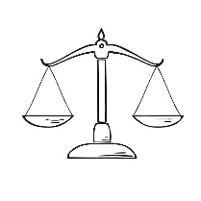**#=_ cIf/ / lrq lar hf]8f ldnfpg'xf]; . -&_**

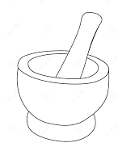v

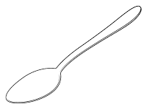r

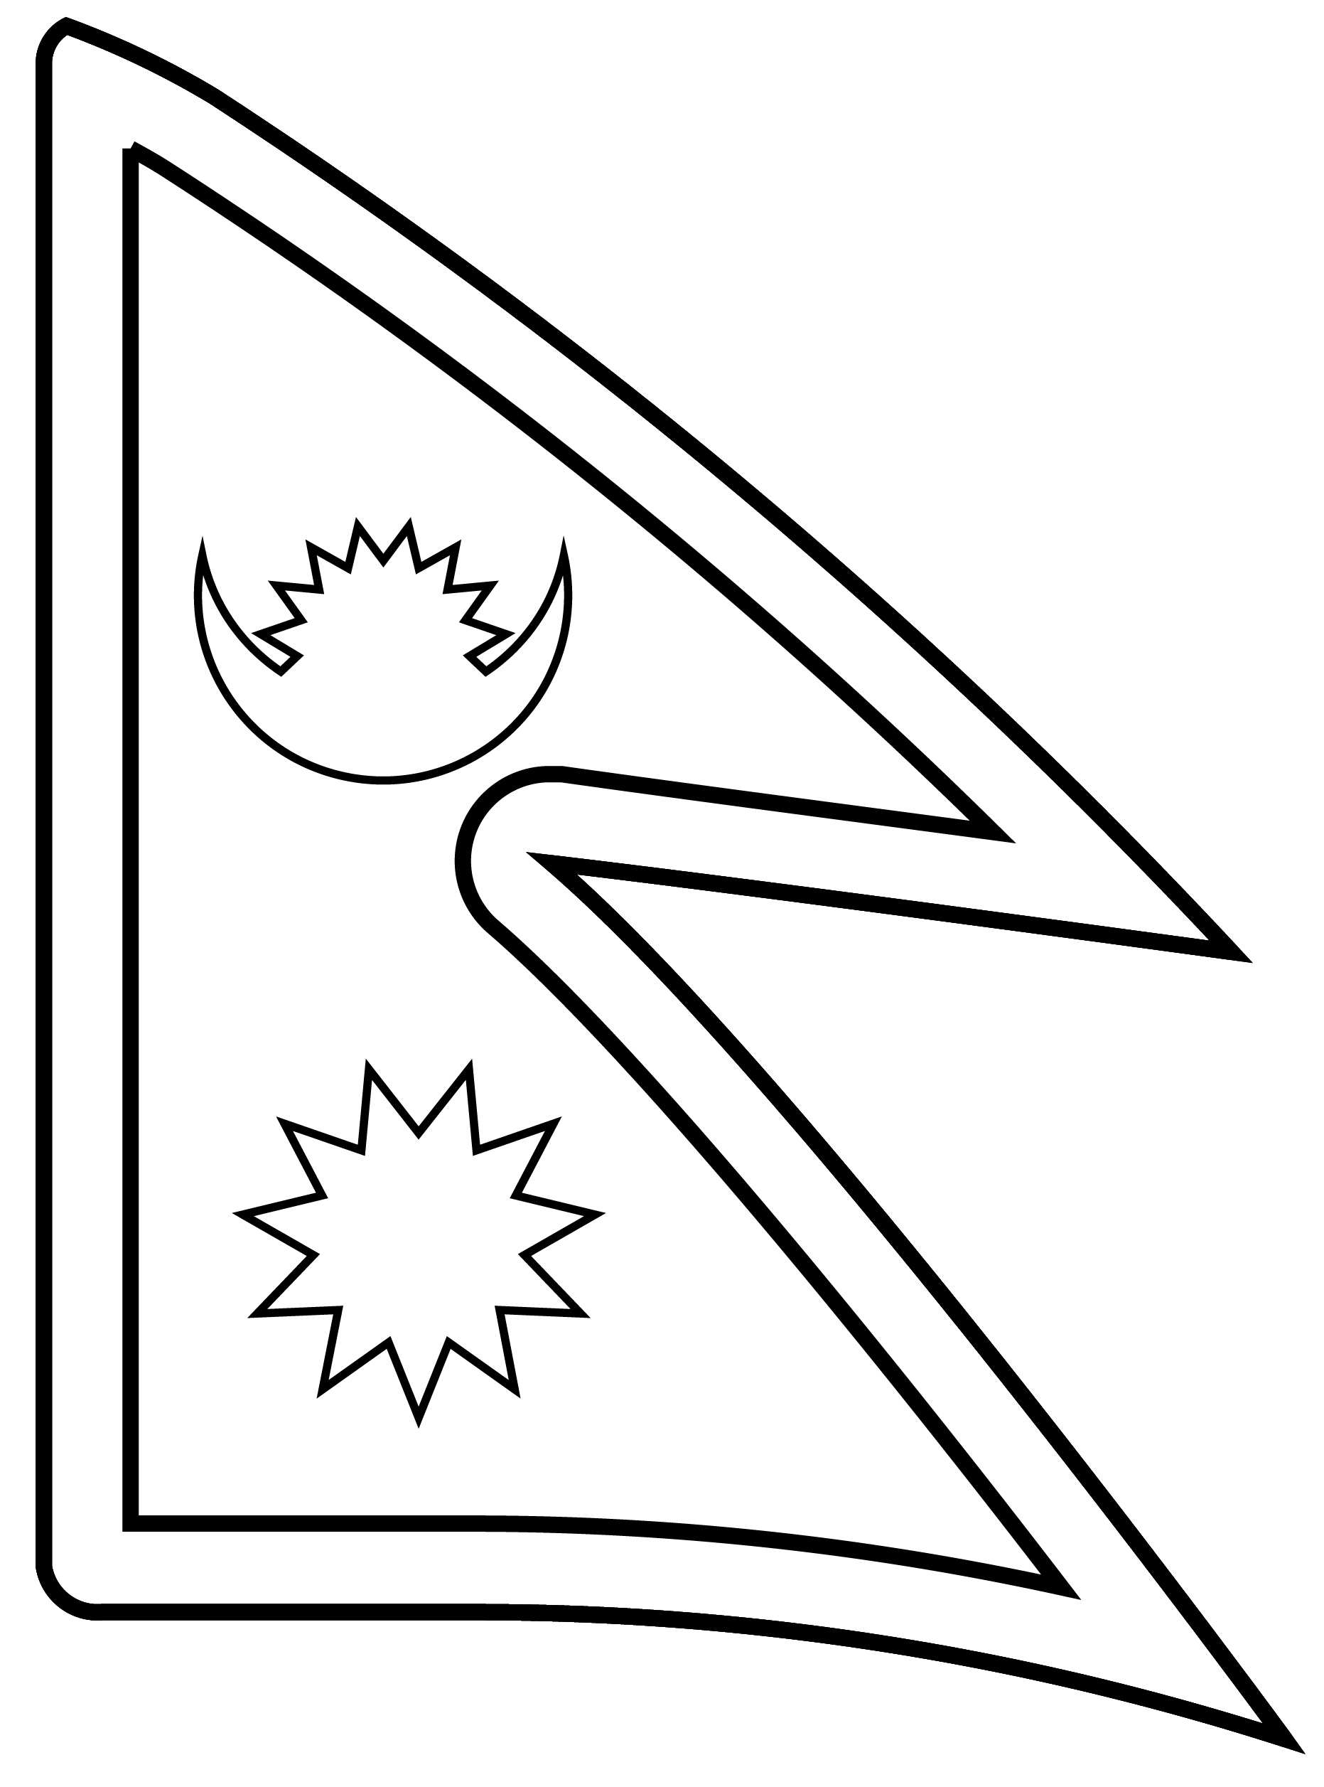h

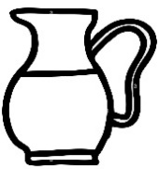6

em

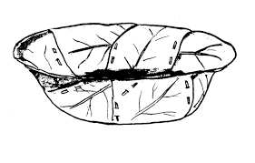8

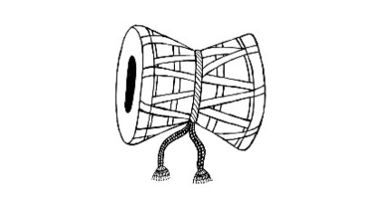t

**$_ lrq x]/]/ ;xL cIf/df uf]nf] -○_ 3]/f nufpg'xf];\ . -%_**

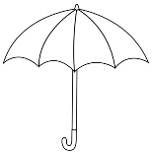

 M 5 s u

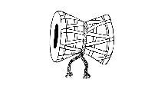 M ~f em g

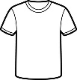 M 0f 3 8

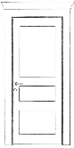 M ª u b

M b w 9

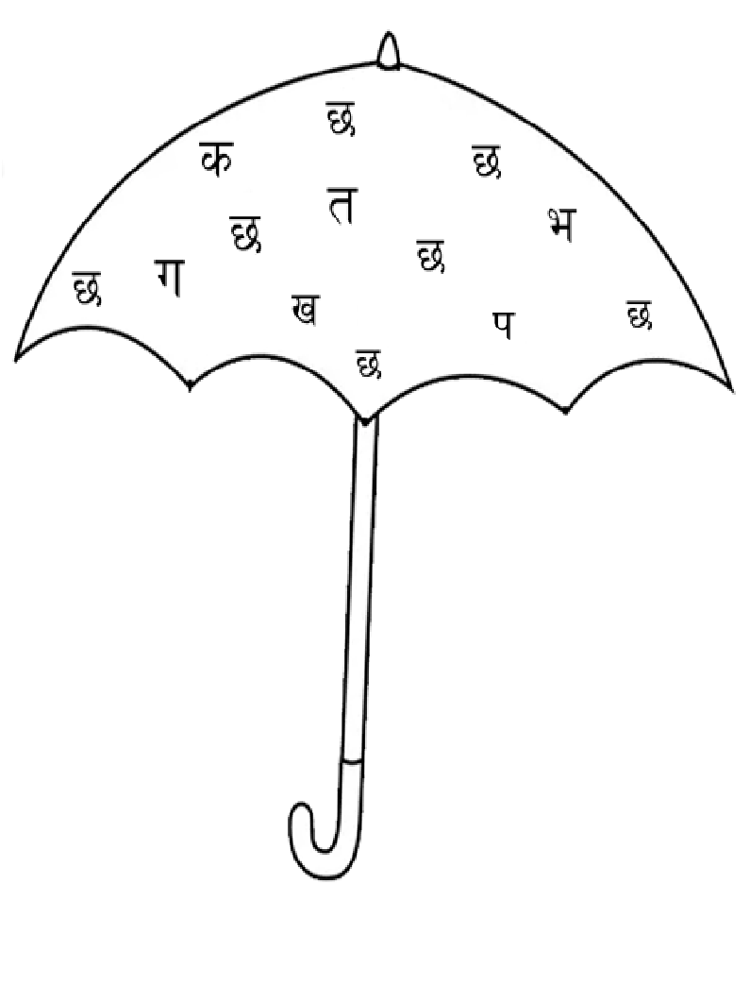**%_ ‘5’ cIf/df uf]nf] (O) 3]/f nufpg'xf];\ . -&_**

**^_ p:t} p:t} b]lvg] cIf/ lar hf]8f ldnfpg'xf];\ . -%_**

5 0f

0f 5

~f g

g ~f

7 7

**&=_ ‘s b]vL ª’ ;Dd n]Vg'xf];\ . -!)_**

________ ________ ________

_______ ________

**\*=_ tnsf] lrqdf /ª eg'{xf];\ . -%_**

**;dfKt .**